DIGITAL FORENSICS BOOTCAMP
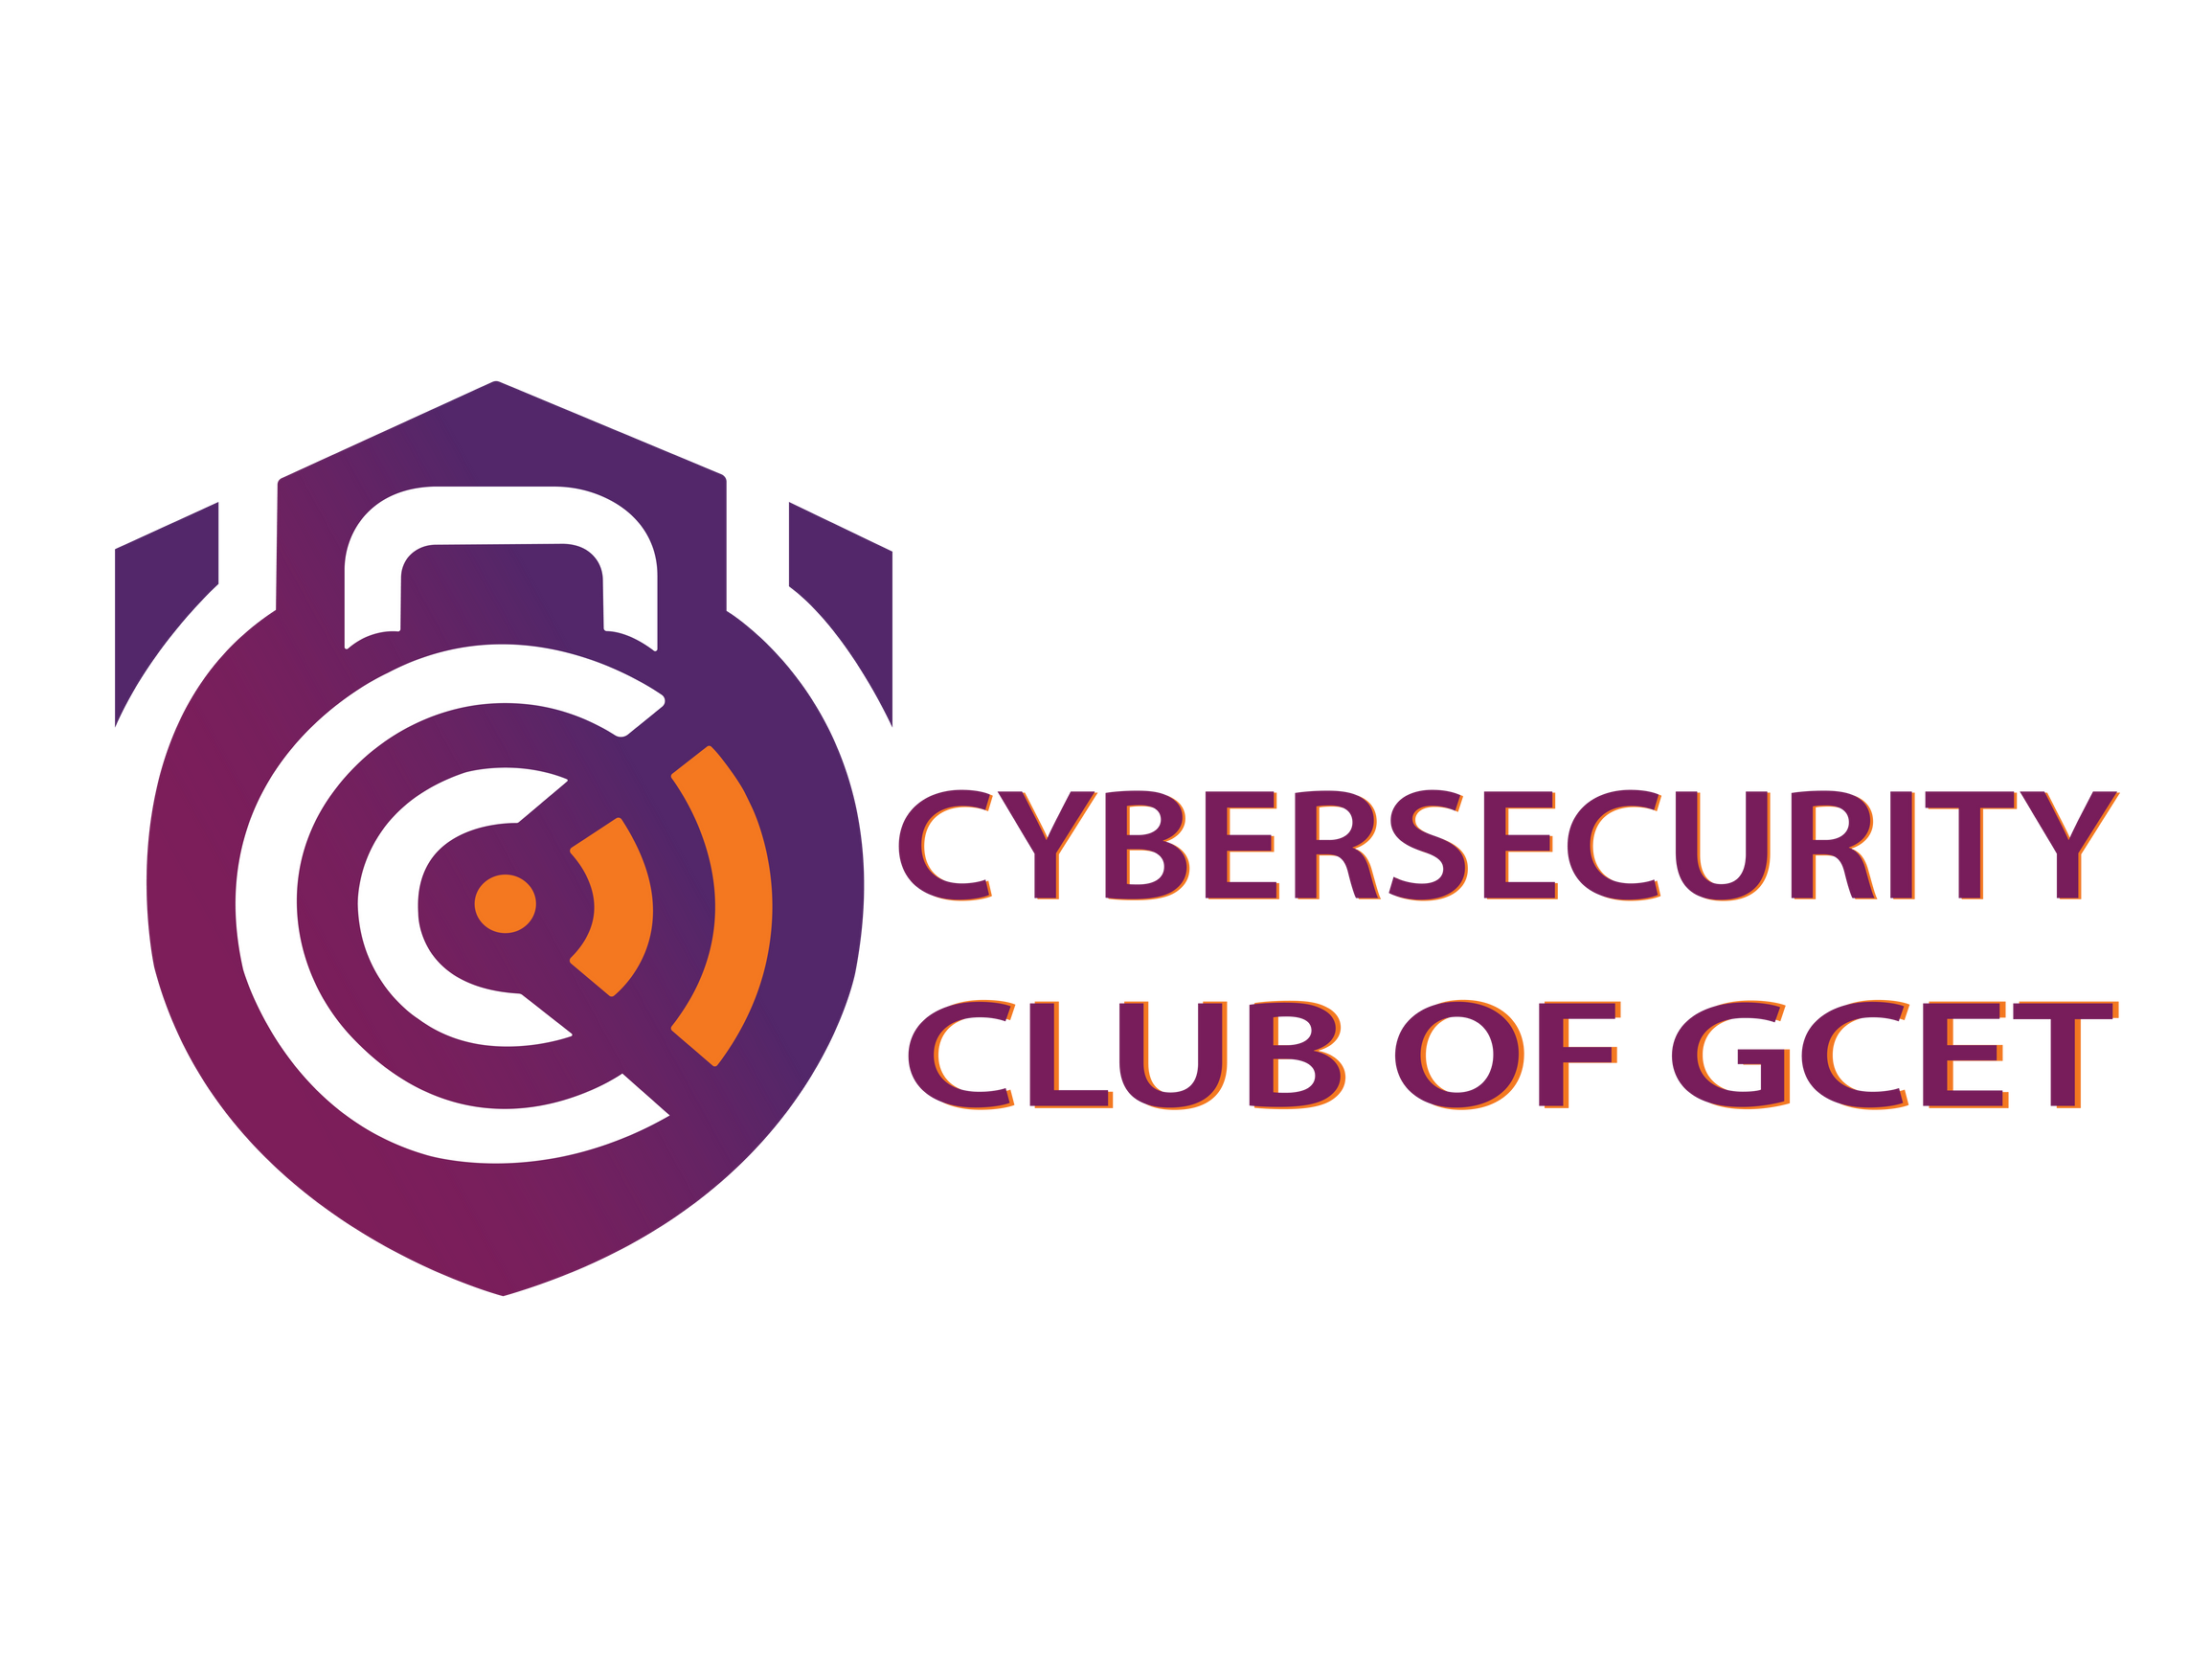


Geethanjali College of Engineering and Technology
Cheeryal (V), Keesara (M), R.R.Dist.-501 301

REPORT

EVENT DETAILS:

Date : 20th June 2024, 21st June 23, 2024
Venue : Geethanjali College of Engineering and technology.
Number of participants : 75

FACULTY CORDINATORS:

Mrs. B Mamatha Mrs. Hima Bindu

STUDENT CORDINATORS:

- Dhanush
- Muzammil
- Pragnya
- Reethika
- Madhiha
- Sreekaree
- Ratnakeshav
- Sanjana
- Ashish
- Rohith
- Sharanya
- Vishishta
- Indu
- Yagnesh

EVENT DESCRIPTION:

Digital Forensics bootcamp has been conducted by the Cybersecurity club of GCET so that the students of Cybersecurity branch and even students from various branches can get to have knowledge in the field of digital forensics and so that the student can get hands-on experience on the practices of how to trace the digital footprints left online. The main aim of the event has been achieved and students have learnt the topics which were taught.

DAY-1 – 20th June 2024
The day-1 of bootcamp had two enlightening sessions.

Session 1 : Introduction to Digital Forensics and basics of Digital Forensics
Speaker Name : Akhil Gabbeta, CEO & Founder – Hackerinthehouse
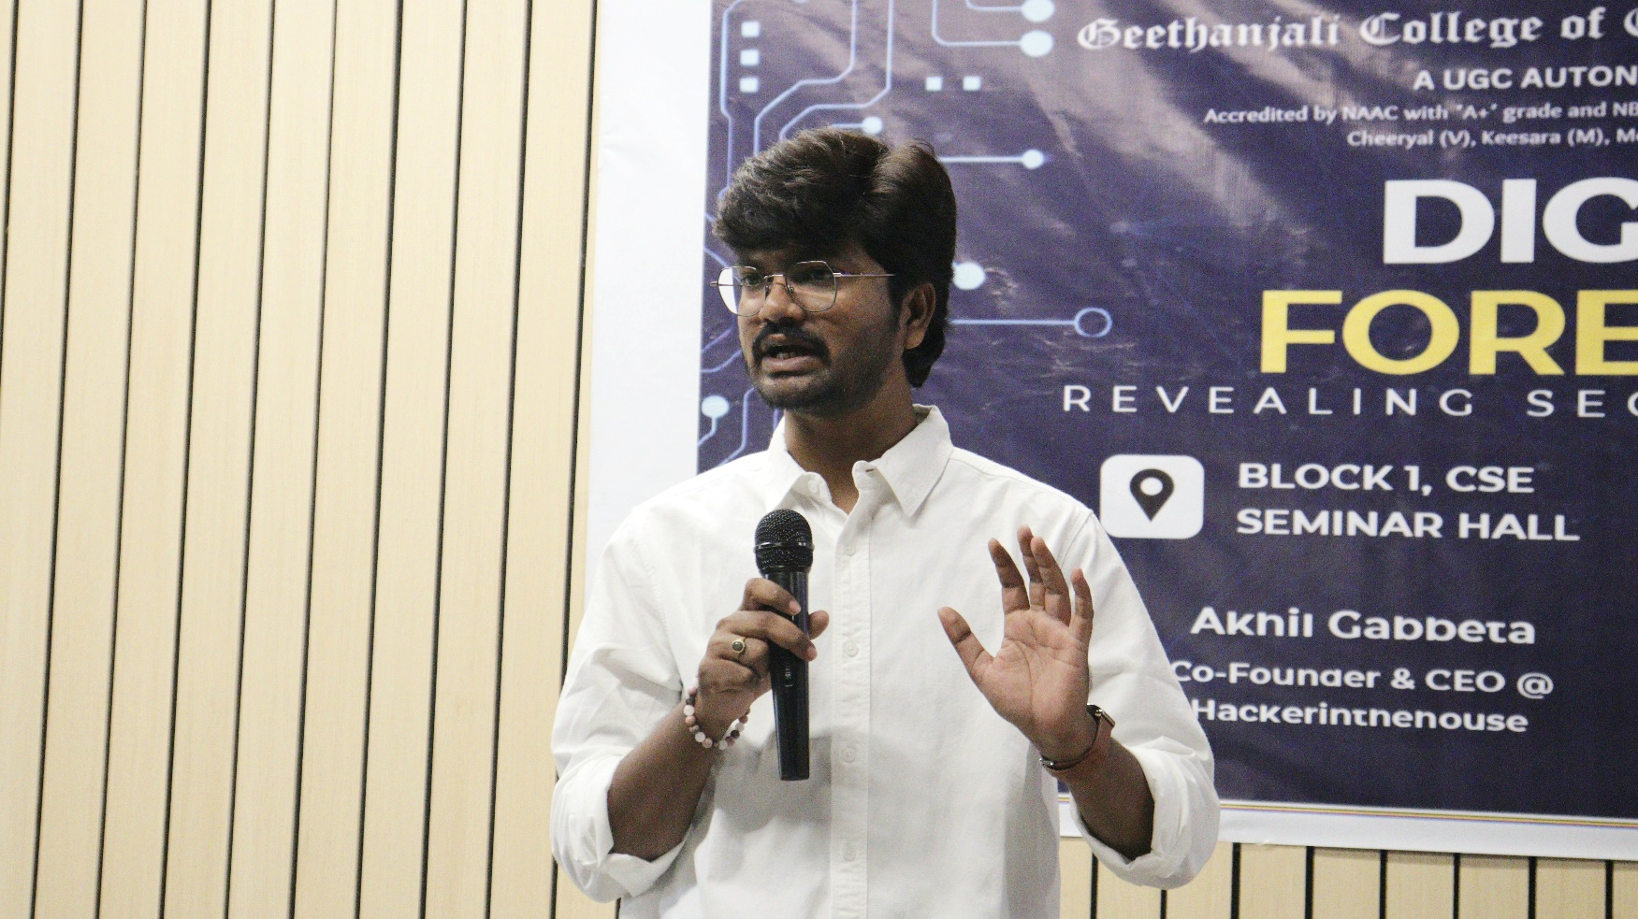

The first session was conducted by the CEO & the founder of the company HackerInTheHouse. The session started off with an introduction to digital forensics and cybersecurity so that the students who are unaware of digital forensics and it’s concepts will get to know what they are about to learn for the 2 days.
The session was a knowledgeable one which went quite interactively and with Q&A sessions along with the session.

Session 2 : Practical Session on basics of Digital Forensics
Speaker Name : Soumyaranjan Pradhan, Co-Founder of HackerInTheHouse

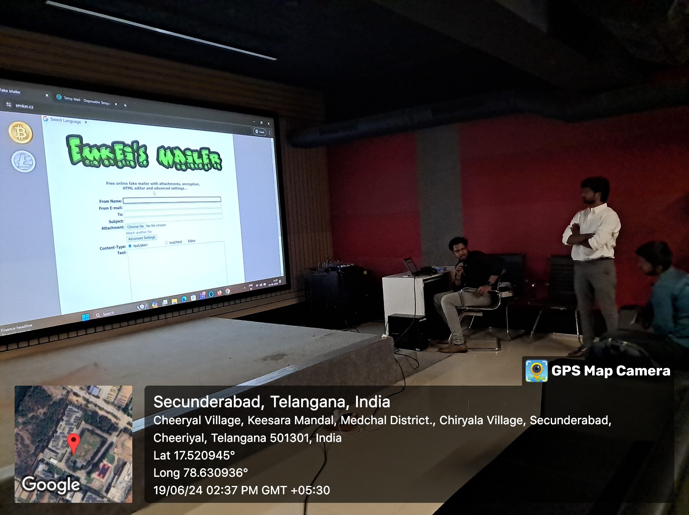

The second session of bootcamp was skillfully conducted by Soumyaranjan Pradhan, the accomplished co-founder of HITH. With precision and insight, he covered critical facets such as web application security, retrieval of deleted files and a live view of how fake mails work has been shown using the tool Emkei’s fake mailer. Attendees were treated to a comprehensive overview, gaining valuable insights into the intricate layers of safeguarding web applications in an era where digital security demands constant vigilance and adaptation. An existing tool has been taught to the students which was an insightful session for the students as the tool helps in the retrieval of all the lost data.

DAY-2 – 21st June 2024
The second day of digital forensics bootcamp , featured a dynamic agenda that comprised an engaging workshop in parallel to a session.

Session 1 : Advanced concepts of Digital Forensics
Speaker Name : Soumyaranjan Pradhan , Co-Founder of HackerInTheHouse

On the second day of Digital Forensics Bootcamp, the first session was conducted by Soumyaranjan Pradhan proved to be an invaluable exploration into the foundational aspects of Digital Forensics. Pradhan, drawing from his wealth of experience, provided comprehensive insights into the advancement of how to trace digital footprints. This insightful session laid a robust foundation for the subsequent workshop, ensuring that participants possessed the requisite knowledge to engage meaningfully in the hands-on activities that followed.
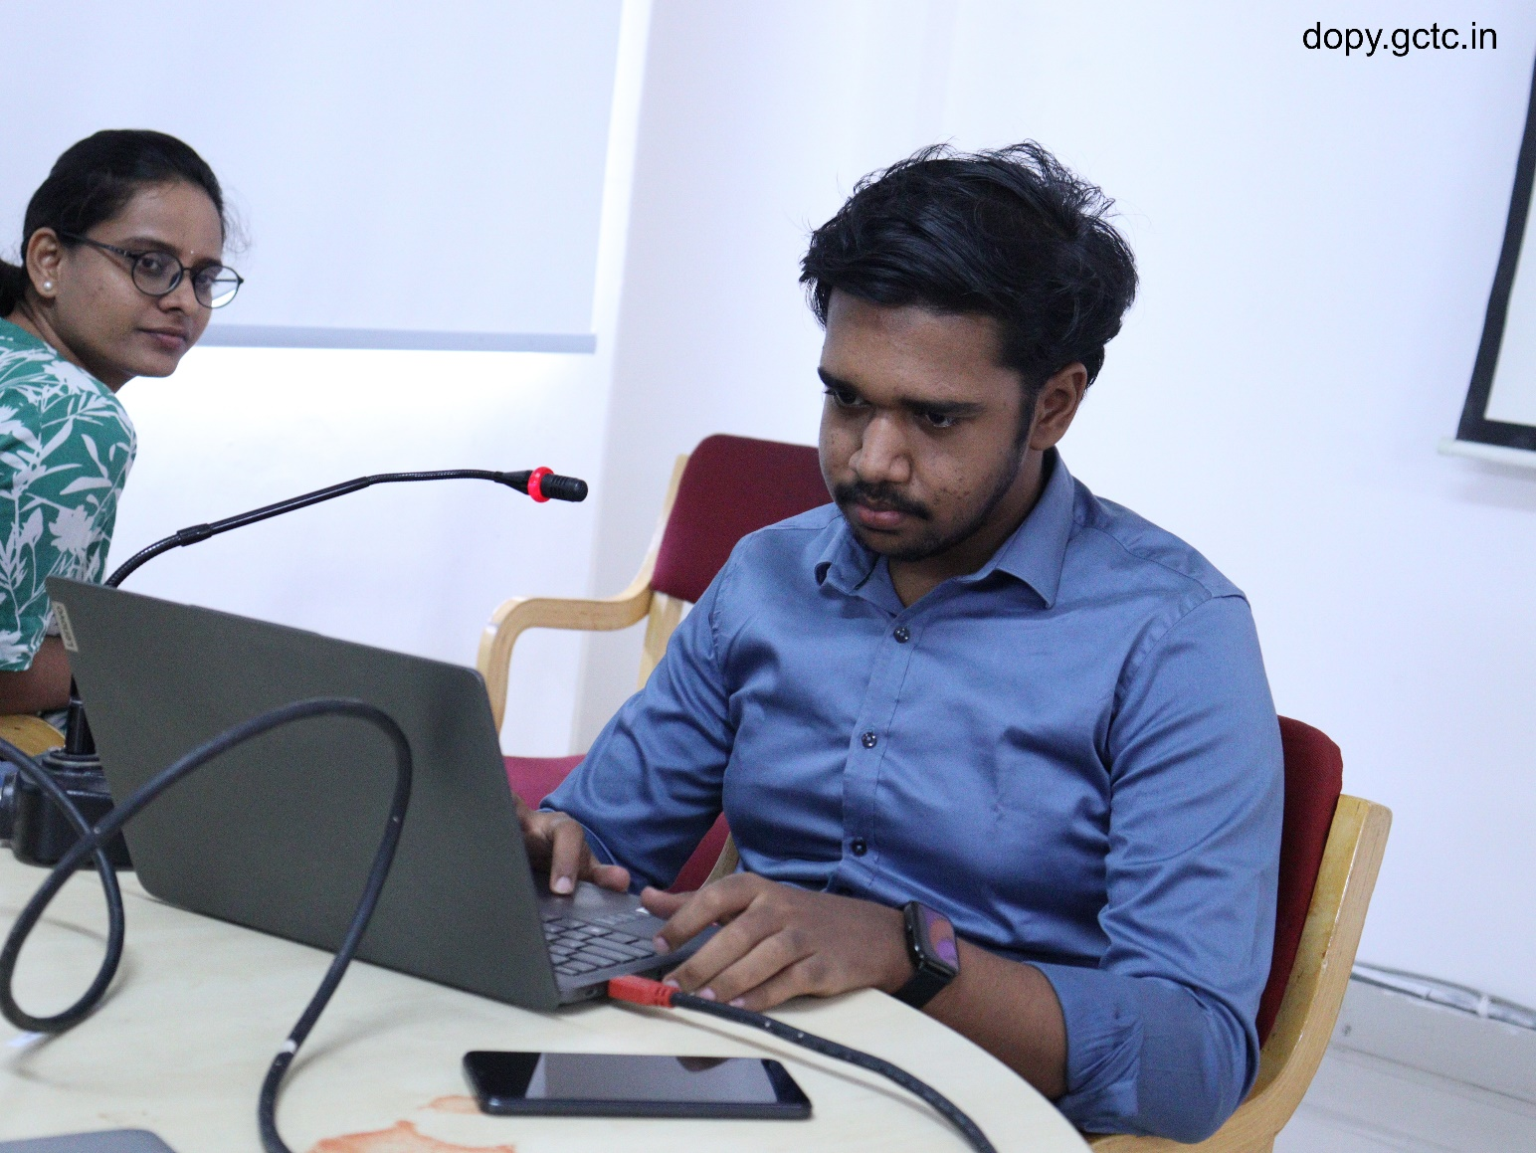

Workshop : Advanced Concepts of Digital Forensics
Speaker Name : Soumyaranjan Pradhan, Co – Founder of HackerInTheHouse

The workshop on the second day of Digital Forensics bootcamp was expertly conducted by Soumyaranjan Pradhan. Under the theme "Digital Footprints" Pradhan provided participants with invaluable insights into the intricacies of these domains. The workshop delved into the practical aspects of online security, with a focus on fundamental commands essential for retrieving details from websites. Pradhan's hands-on approach was evident as he adeptly utilized tools such as Ghunt, Sherlock, Passmute and autopsy to demonstrate real-world applications of Digital security principles. The participants were not only introduced to the theoretical foundations but also gained practical, tangible experience in employing tools vital for safeguarding web surfing in an ever- evolving digital landscape. Pradhan's engaging and informative workshop left attendees with a richer understanding of Digital Forensics.
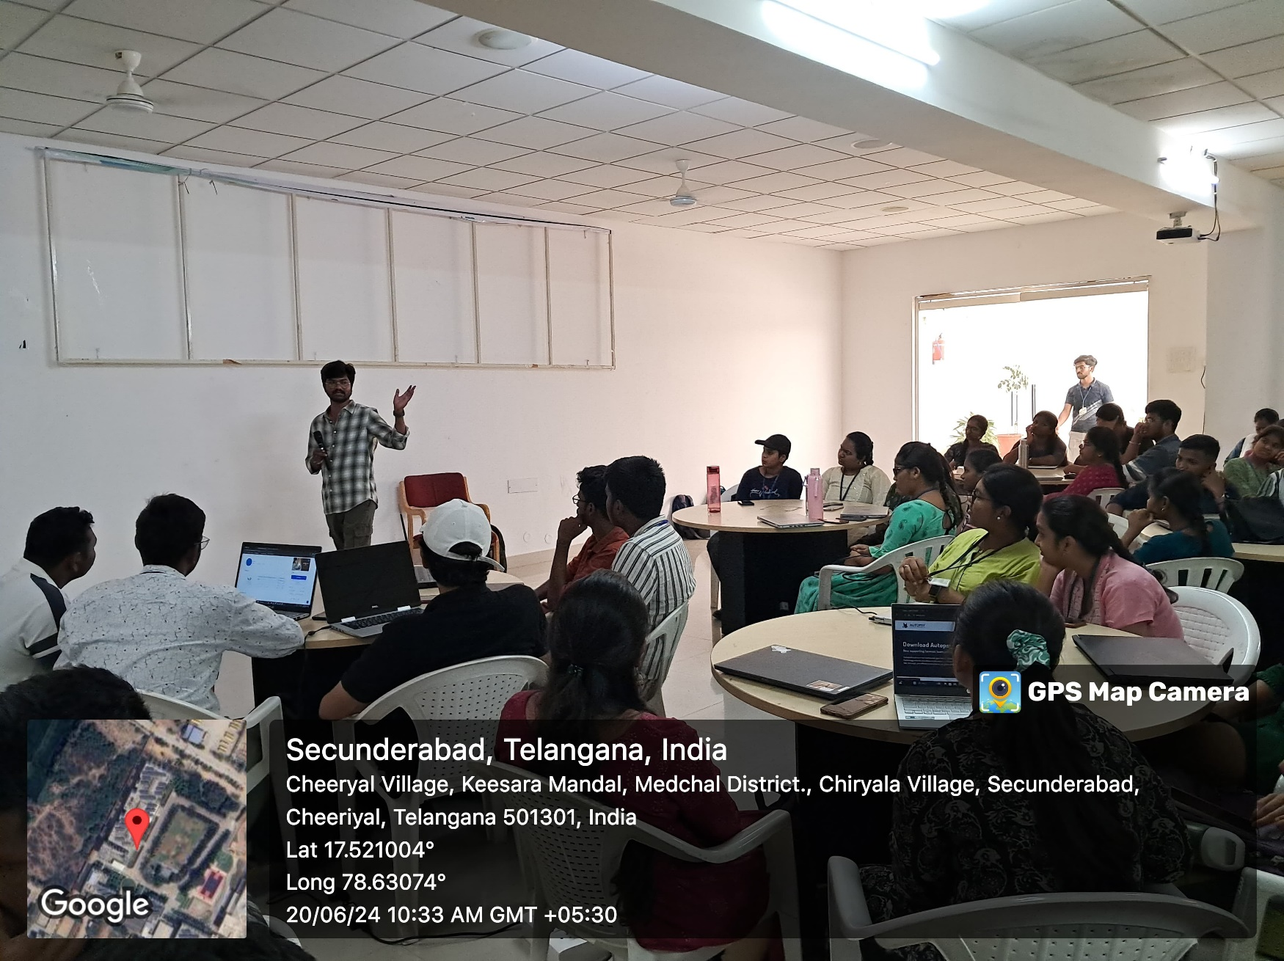

Captures of the event:

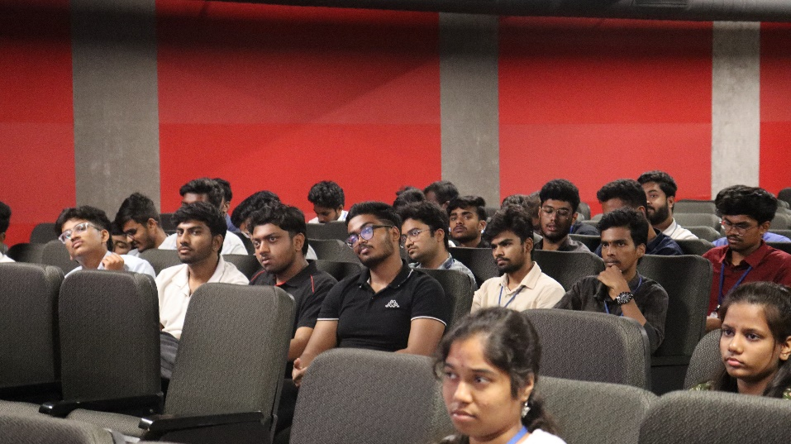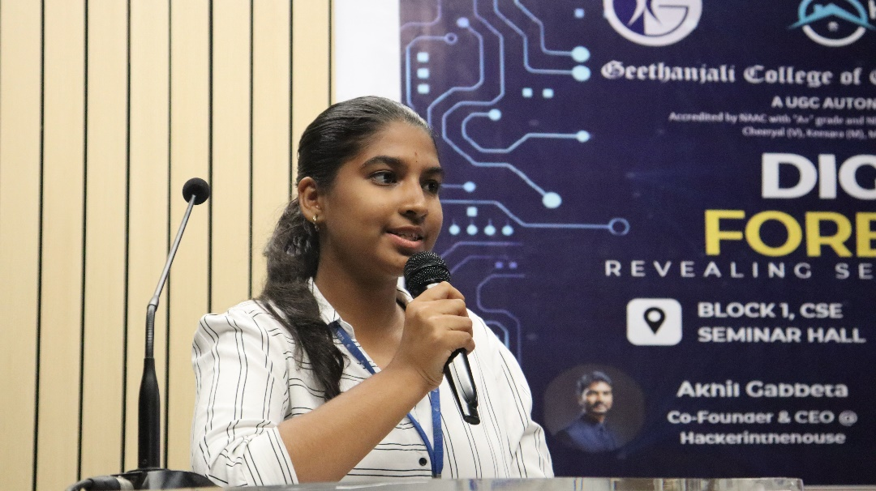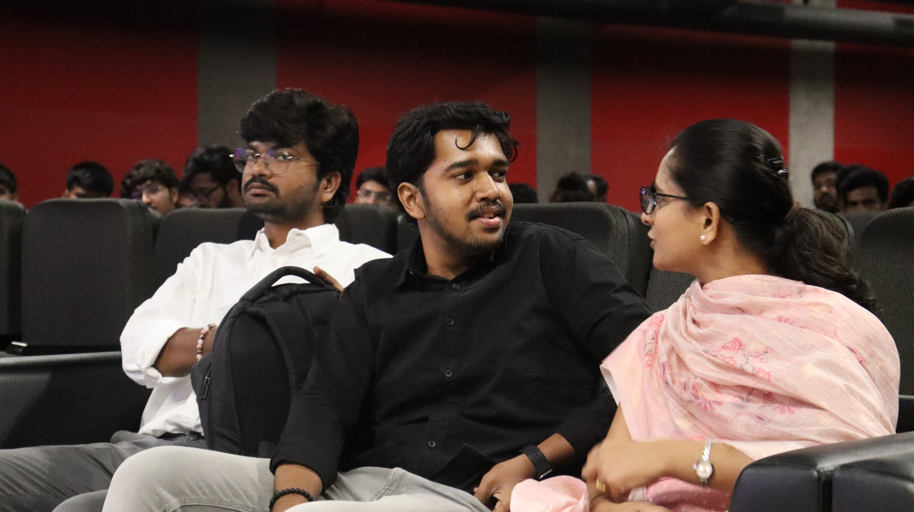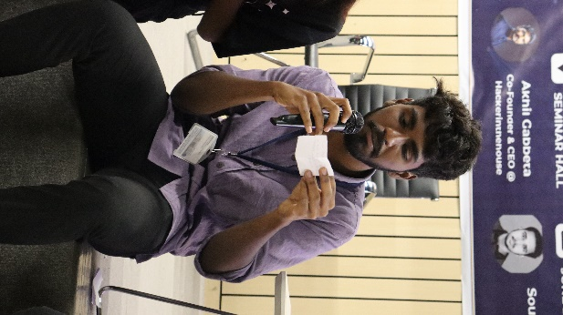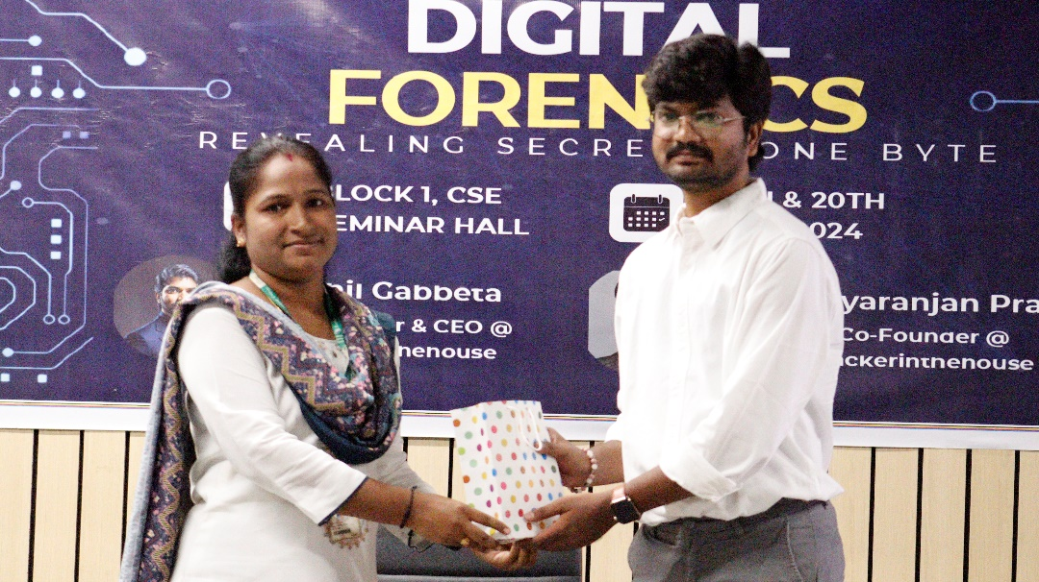
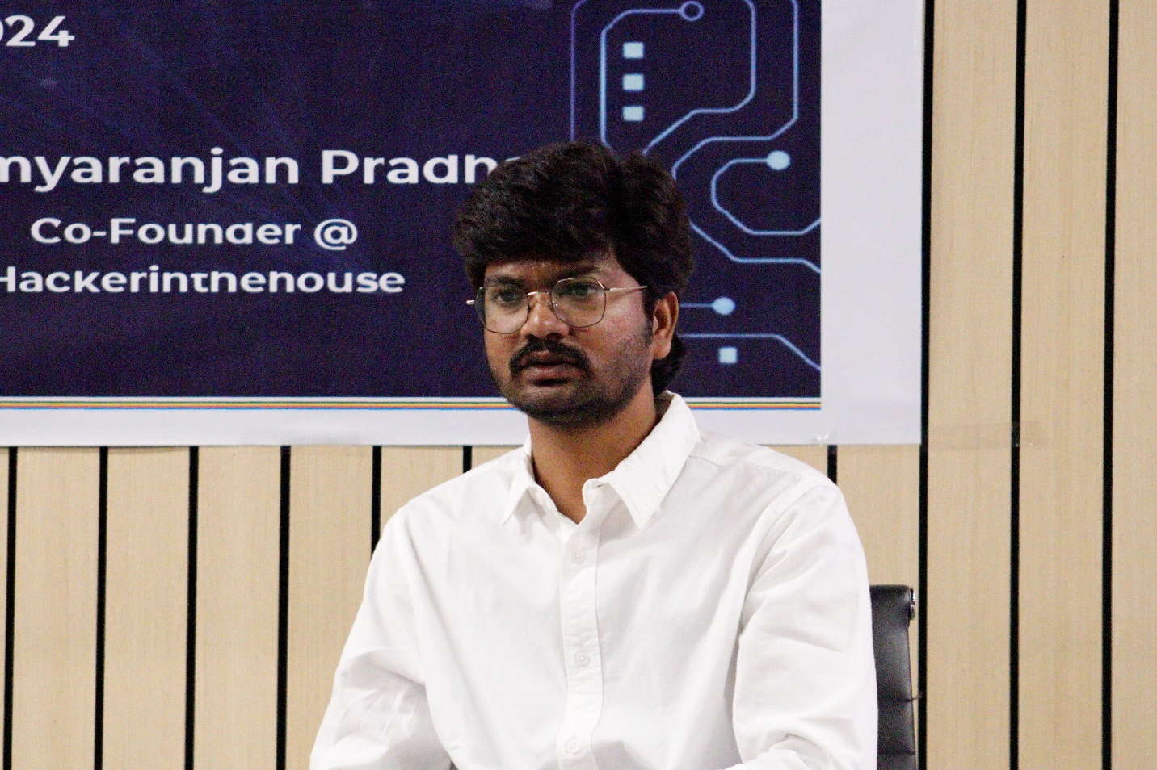

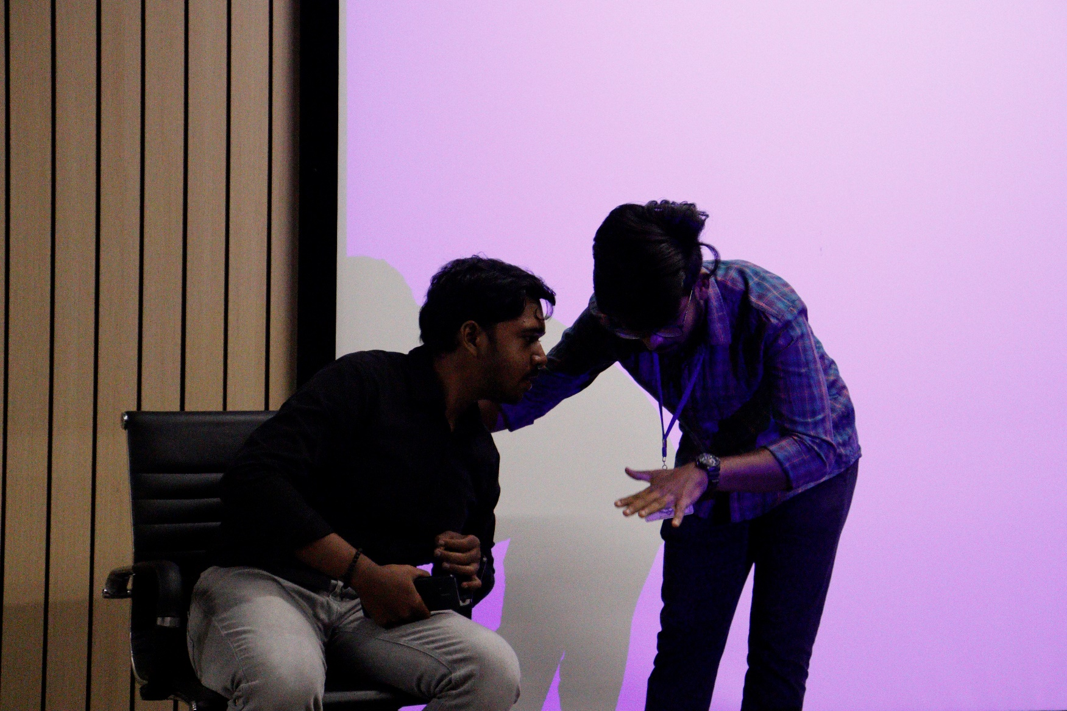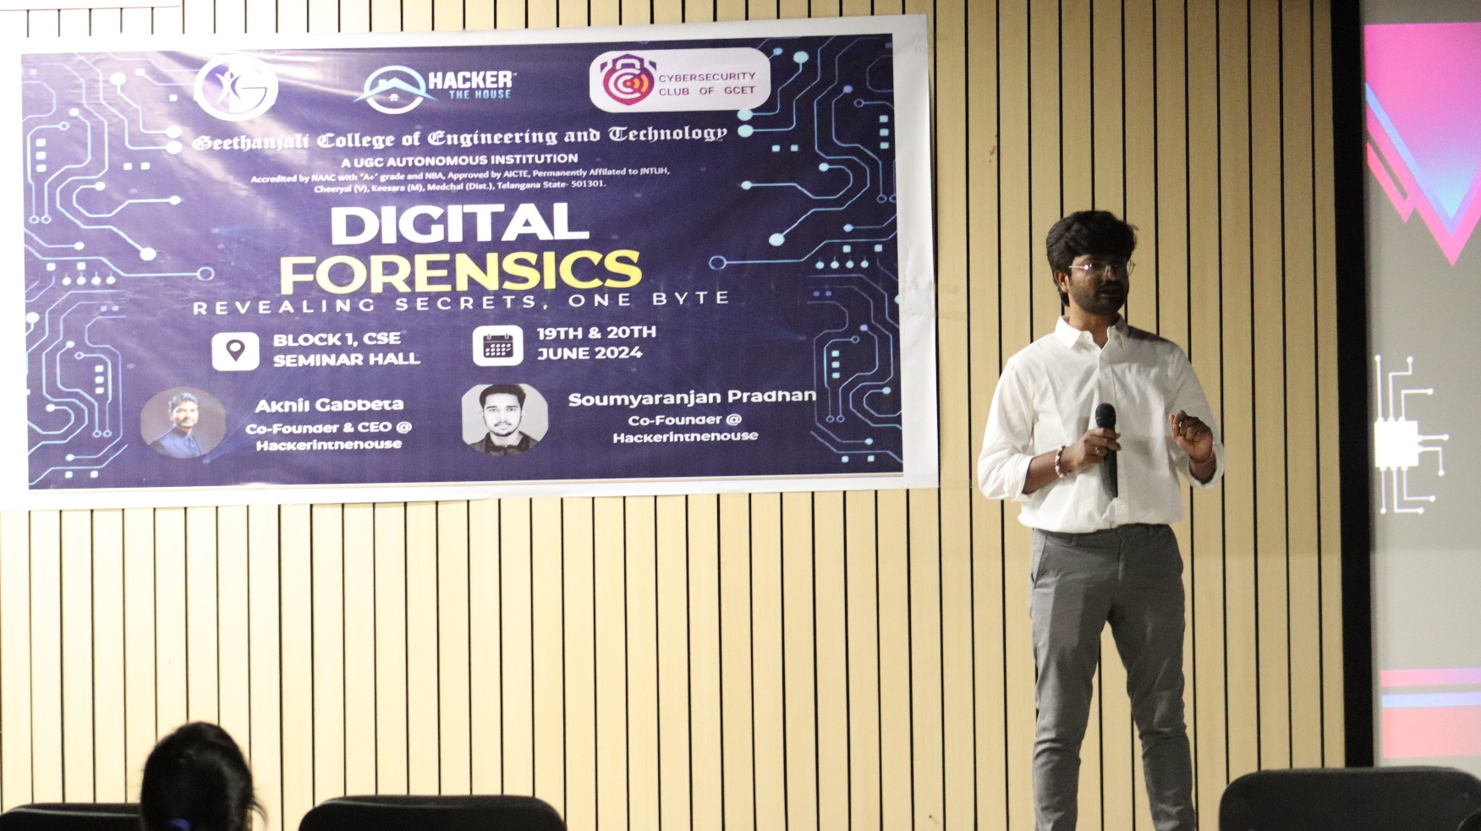

FEEDBACK:

The Digital Forensics bootcamp blended physical elements, offering a well- organized platform for both sessions and workshops. The bootcamp incorporated both fun- filled and skilled events through-out both the days.

The sessions were enlightening, providing concise insights into addressing crucial topics like cyber crimes and many more. The workshops delivered experiences across diverse domains, such as file retrieval and digital forensics. The inclusion of engaging quizzes during virtual event not only kept students involved but they also worked on their own. Overall, a commendable event that successfully combined education and interactivity.

